ONTA NEWSLETTER
Organization of Nematologists of
Tropical America
http://www.ontaweb.org
Volume 41, Issue 2 November 2010
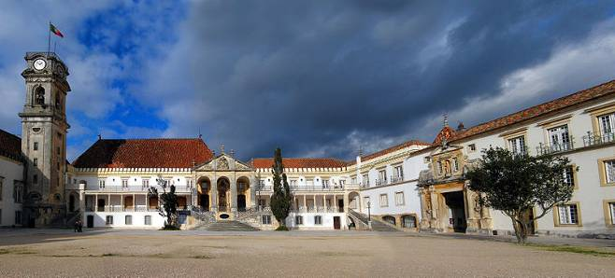
University of Coimbra, Portugal (Wikipedia)

XLIII ONTA 2011 MEETING
September 4-9, 2011 ~ Coimbra, Portugal

The 43rd Annual ONTA Meeting will be held at the University of Coimbra, Portugal.
A preliminary draft of the scientific program includes 11 sessions plus posters. The first part of the week will be dedicated to oral, poster presentations and an excursion day. Thursday afternoon (September 8th) will be reserved for a symposium on Pinewood Nematode, an exotic nematode pest, which is causing serious pine decline in Portugal. A workshop on entomopathogenic nematodes is also planned at the end of the meeting.
Special registration fees are required for attending this workshop.
Continued in the adjacent column

The tentative scientific sessions include
1) Biodiversity, ecology and evolution
2) Plant-nematode interactions
3) Nematode-other organisms interactions
4) Nematode secretions-chemical nature and function
5) Plant defenses against nematodes
6) Molecular mechanisms of plant resistance and nematode virulence
7) Impact of nematodes on plant growth and yield
8) Nematode epidemiology, modeling and management
9) Alternatives to methyl bromide for nematode management
10) Root-knot nematodes, emerging species and identification challenges
11) Nematode systematics and identification, classical and molecular approaches
12) Insect nematodes
13) Pine wilt disease in Europe
A student poster competition and travel awards are also planned.
Registration cost for the meeting (not including the workshop) is estimated at 380 Euros (≈ US $500). Registration will cover welcome reception, lunches, coffee breaks, field excursion, banquet and attendance to all scientific sessions. Deadline for registration at reduced cost is May 31st. Abstracts must be submitted by June 30, 2011. This meeting will facilitate interactions between nematologists from tropical and temperate regions.
ONTA extends its thanks and appreciation to Isabel M. de O. Abrantes (University of Coimbra), Chair of the Local Arrangements Committee and her collaborators Maria Teresa Martins de Almeida (University of Minho), Isabel Luci Conceiçăo (University of Coimbra), Maria José Cunha (Agriculture High School of Coimbra), Manuel Mota (University of Évora), Post Docs and students. Further information about the meeting will be available soon on the English and Spanish versions of ONTA’s website (http://www.ontaweb.org).

Inside This Issue
1-3 | ONTA 2011 Meeting, Coimbra, Portugal, New ONTA Leaders; Report 2010 Ecuador Meeting
4-7 | 2010 ONTA Awardees, Photos, Minutes of the ONTA Executive Committee Meeting
8-14 | Nematological Initiatives, ONTA Officers

GREETINGS FROM THE PRESIDENT Emma Zavaleta Mejía

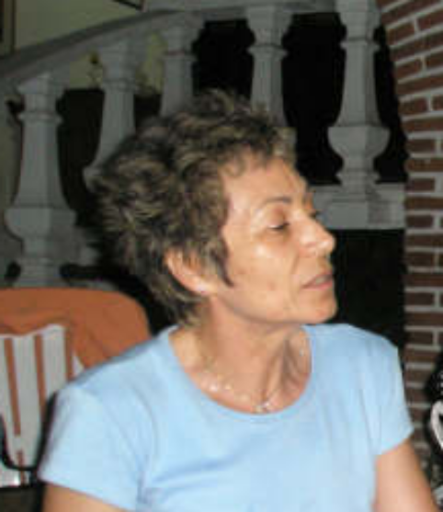

Emma Zavaleta Mejía (Colegio de Postgraduados, Texcoco, México) was inaugurated as President during the XLII ONTA meeting held in Quito, Ecuador, Oct. 3-8, 2010. Emma previously served as Vice-President for the term 2009-2010.

Emma has been involved in many ONTA activities since her inauguration and participated in preparing the scientific program for the meeting in Ecuador. She is in close contact with the president elect Erwin Aballay, Rosa Manzanilla-López, Member at Large of EC, and with Isabel Abrantes, Chair of the Local Arrangements Committee, who are preparing the scientific program and the meeting arrangements at the local level for the coming ONTA meeting in Coimbra, Portugal.

Emma is an outstanding scientist with a pleasant personality. She is known for finding agreements in very difficult and opinionated situations and will lead ONTA with her energetic disposition.

NEW ONTA OFFICER
ONTA VICE-PRESIDENT
Erwin Aballay Espinoza

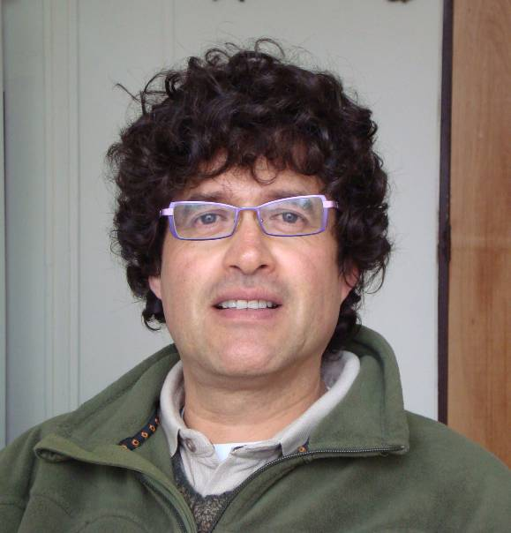

Erwin Aballay Espinoza (Universidad de Chile, Santiago, Chile) was elected ONTA Vice-President in 2010. He will become President at the Meeting in Coimbra, Portugal in 2011.

Erwin has been a very active ONTA member. He is serving on the Executive Committee and on the Editorial Board of Nematropica. He organized the 37th ONTA meeting held in Viña del Mar, Chile, in 2005.

After his election, Erwin has been in contact with Isabel Abrantes and her collaborators planning the scientific program for the ONTA Meeting in Portugal.

His activities also include a cooperation with Nahúm Marbán-Mendoza (Universidad Autónoma de Chapingo, Montecillo, Mexico) for the organization of ONTA’s 2012 Meeting in Mexico.

ONTA members wish Erwin great success in promoting amd improving the Organization.

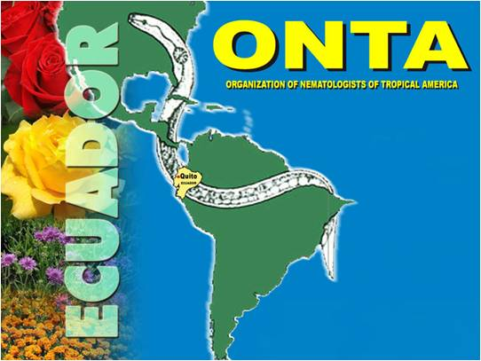

XLII ONTA ANNUAL MEETING REPORT
Quito, Ecuador, October 3-8, 2010

The 42nd Annual Meeting was a successful scientific event in spite of the political turmoil that occurred a few days before the meeting in Ecuador. The political unrest did not prevent the participation of about 60 nematologists from Ecuador and other countries of the world. The fascinating city of Quito and the excellent accommodations provided by the Local Arrangements Committee enhanced the success of the meeting.
Organizers of the Congress included Jenny Escobar (Chair) and her collaborators Carmen Triviño, Betty Tello, Tarcisio Mosquera and Pedro Asanza. These individuals are to be commended for making this meeting possible. The scientific program coordinated by Carmen Triviño and Emma Zavaleta Mejía encompassed a great variety of nematological subjects.
Session topics included:
- traditional and molecular techniques for nematode identification
- biological management of nematodes
- emerging and other damaging nematode parasites such as Meloidogyne ethiopica, Nacobbus aberrans and Rotylenchulus reniformis
- nematode parasites of foliage and flowering ornamentals, fruit trees, banana and vegetables
- nematodes of quarantine significance
- plant nematode interactions
Continued on the adjacent column.

- gene expression
- resistance
- and a course on entomathogenic nematodes organized by Patricia Stock.
These sessions and the excellent oral and poster presentations provided the participants with a wide range of scientific information. The tour of cut flower operations in the vicinity of Quito was an excellent field demonstration of the serious nematode problems caused by lesion, false root-knot and root-knot nematodes to the ornamental industry of the country (see photos below). ONTA members convey their appreciation and thanks to Jenny, Carmen, Betty and Tarcisio along with their collaborators for the organization of this memorable meeting. Photos of the events of this meeting are posted on the ONTA website.

Photos from the Agricultural Tour

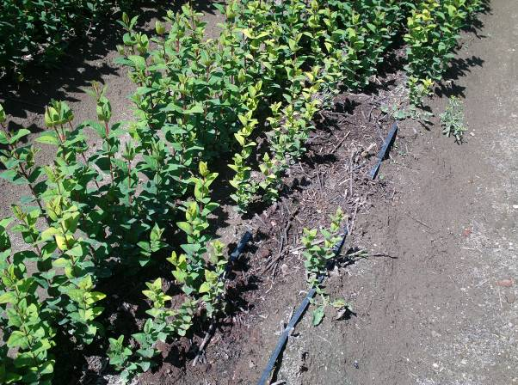

Hypericum sp. plants stunted by root-knot nematodes.

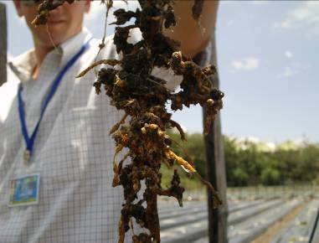

Roots infected by the false root-knot nematode (Nacobbus aberrans). Note large galls and severe distortion of the root system.

ONTA STUDENT POSTER COMPETTION
The Student Poster Competition was kindly sponsored by the ONTA Foundation through a generous gift from Rodrigo Rodríguez Kábana. The following students were recognized:

Damaris Godinez-Vidal from Colegio de Postgraduados, Montecillo, Mexico was awarded $500 for her studies on the nematostatic activity of a phytoalexin (capsidiol) produced by chili pepper roots on Nacobbus aberrans juveniles. She received also a book titled Mononchida, the predatory soil nematodes by Ahmad W. and M.S. Jairaipuri.

Patricia D. Navarro from the Dept. of Entomology, University of Arizona, Tucson, USA, was awarded $300 for her studies on the antagonsisrtic effect of the fungus, Fusarium oxysporum, on the entomopathogenic nematode Heterorhabditis sonorensis.

Israel Lima-Medina from Universidade Federal de Pelotas, Pelotas, Brazil, was awarded $200 for his studies on the response of Irish potato varieties to Meloidogyne ethiopica and M. mayaguensis.

ONTA TRAVEL AWARDS

Charles Overstreet, chair of the ONTA Foundation Committee informed that two travel awards of $700 each were kindly sponsored by the ONTA Foundation through generous gifts from Rodrigo Rodríguez Kábana and Charles Overstreet.
The following students received these awards:

Damaris Godinez-Vidal from Colegio de Postgraduados, Montecillo, Mexico.

Iván Castro Lizazo, from Havana Agricultural University, Cuba.

.

2010 ONTA AWARDEES
The following ONTA members were recognized during the banquet at the 42nd ONTA meeting held in Ecuador.
Charles Overstreet (Louisiana State University, USA) received the Honorary Member Award for his outstanding contributions to the Organization and the ONTA Foundation.
Paola Lax (Universidad Nacional de Córdoba, Argentina) received the Distinguished Service Award. Paola was acknowledged for her skills and dedicated efforts in reorganizing ONTA membership files and collecting ONTA dues.
Rosa H. Manzanilla-López (Rothamsted Research, UK) received the Special Award. Rosa was recognized for her long standing services to the Organization and for her dedicated efforts in promoting teaching activity in Nematology and training new nematologists in Mexico and Latin America.
Jenny Scarlett Escobar Goyes (Bayer Crop Science, Guayaquil, Ecuador) and Marta Susana del Toro (Universidad de Cuyo, Mendoza, Argentina) received a Special Award of Appreciation. Jenny was recognized for her support of ONTA activities and for organizing three ONTA meetings in 1981, 2003 and 2010. Susana was acknowledged for her long standing involvement in ONTA activities by organizing an ONTA meeting in Argentina in 1998 and teaching and training new nematologists in the Central Andean Region of Argentina.

ACKNOWLEDGMENT
ONTA thanks Michiel Thijssen from Brill Academic Publishers, Leiden, The Netherlands for donating the book titled Mononchida, the Predatory Soil Nematodes by Ahmad W. and M.S. Jairaipuri (2010), D. J. Hunt and R. N. Perry (Series Editors), Nematology Monographs and Perspectives volume 7, Brill, Leiden-Boston, 298 pp. This book was bestowed to the first place winner of the student poster competition. ONTA greatly appreciates
Michiel Thijssen’s support.

SELECTED PHOTOS OF ONTA AND STUDENT COMPETITION AWARDEES
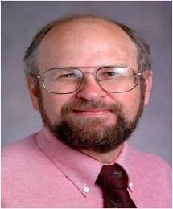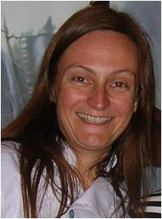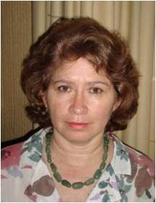

Charles Overstreet Paola Lax Rosa Manzanilla-López
Honorary Member Award Distinguished Service Award Special Award

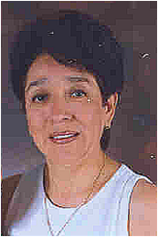

Jenny Escobar -Goyes Susana del Toro
Special Appreciation Award Special Appreciation Award

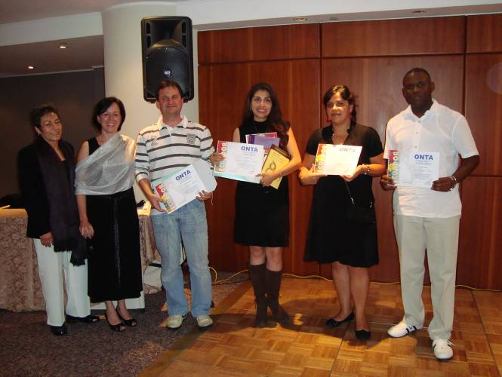

Student Poster Competition Ceremony. From the left: Vice-President Emma Zavaleta, President Patricia Stock, Cesar Bauer Gomes representing student Israel Lima-Medina who returned home before the ceremony, student Damaris Godinez-Vidal (1st place and travel award winner), student Patricia Navarro (2nd place winner) and student Iván Castro Lizazo (travel award winner).

ONTA LONGSTANDING MEMBERS ATTENDING THE ECUADOR MEETING

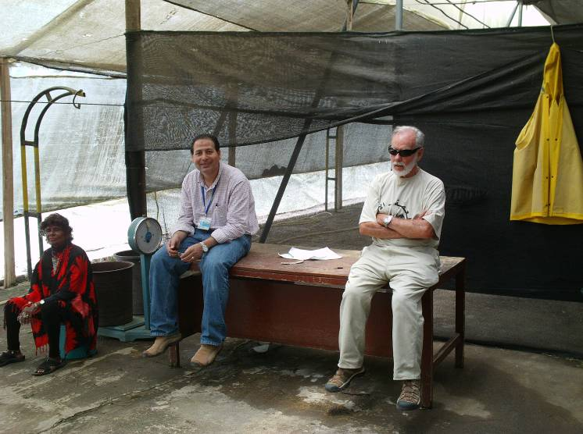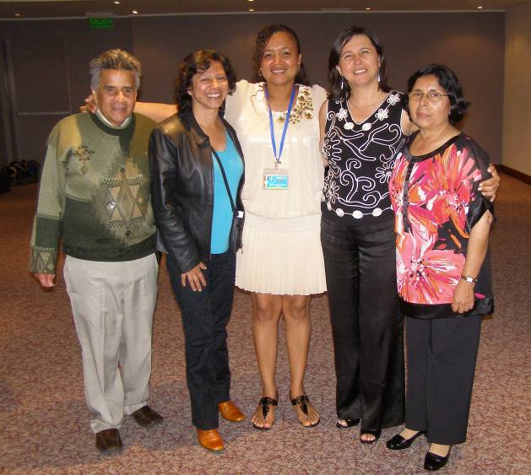

From left: Sorojan Mankau (USA), Fehiem Elbora (USA), Ron Mankau (USA), Rafael Navarro (Colombia), Bertha Gaviria (Colombia), Betty Tello (Ecuador), Gladis Muñera (Colombia), and Carmen Triviño (Ecuador). Ron Mankau and Rafael Navarro have been involved for many years in ONTA activities. Rafael Navarro attended the first official ONTA Meeting held in Sarasota, Florida in 1968 after the foundation of the Organization at the International Symposium of Tropical Nematology in Puerto Rico, in 1967.

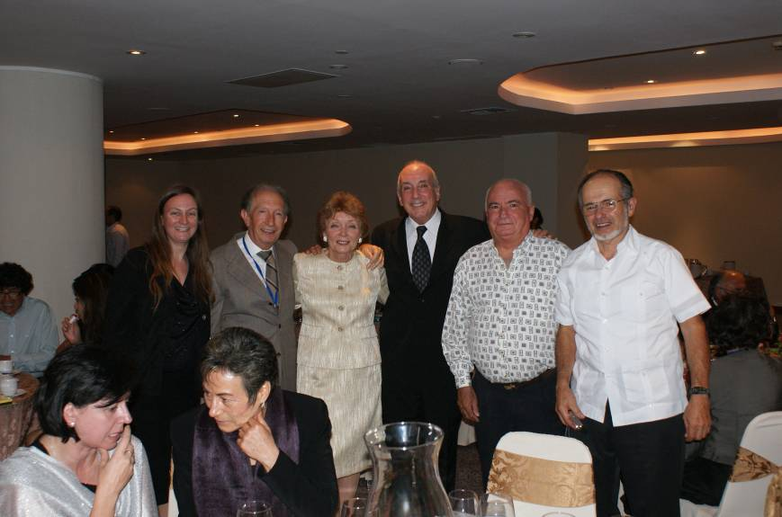
From the left, first row: Patricia Stock (USA) and Emma Zavaleta (Mexico). Second row: Paola Lax (Argentina), Renato Inserra (USA), Julia Meredith (USA), Marcelo Doucet (Argentina), Emilio Fernandez (Cuba) and Rodrigo Rodríguez-Kábana (USA).

ONTA Executive Committee Meeting 2010

This meeting was started on October 3 and continued October 7, 2010, at lunch time at the Hotel Hilton Colon, Quito.

ONTA officers present were: Erwin Aballay, Wilfrieda Decraemer, Jenny Escobar, Renato Inserra, Paola Lax, Rosa Manzanilla-López, Rodrigo Rodríguez-Kábana, Patricia Stock, and Emma Zavaleta Mejía. Major issues discussed included the following topics:

- Nematropica online. Concerns and advantages of having Nematropica online, both for the journal and the Organization, were discussed. An evaluation of the effect of this change will be conducted in 2011, especially during the initial phase of the change of the Journal’s format. The proposal received from Katheryn S. Lawrence (Editor-in-Chief of Nematropica) to be replaced at the end of her term by Patricia Donald (USDA, ARS, Jackson, Tennessee) was well received and approved by the EC.
- ONTA Foundation. The ONTA Foundation granted funds to two students to attend the Meeting in Ecuador. Charles Overstreet was in charge of the Travel Award Grant Committee that selected the students.
- Results of the Elections for New Vice President. Erwin Aballay Espinoza was elected to the office of Vice President.
- Financial Costs of the Meeting in Ecuador. The financial situation of the meeting in Ecuador was discussed with Jenny Escobar and Renato Inserra who assisted Jenny in collecting the registration costs from members in the United States. It was agreed that no registration fees could be refunded to those delegates who cancelled their attendance to the meeting at the last minute due to the political conditions in Ecuador.
- Next ONTA Meeting. Isabel Abrantes’s invitation to host the 43rd Annual Meeting in 2011 in Coimbra, Portugal was accepted.
- Future ONTA Meetings. A report on the organization of the International Nematology Congress to be held in South Africa in 2014 was presented by Rosa Manzanilla-López. The EC emphasized the need to help the South African nematologists in this difficult enterprise.
- Taxonomical award. A special award for an outstanding taxonomical work was proposed by Rodrigo Rodríguez-Kábana. The proposal was discussed by the EC.

ONTA Business Meeting

The ONTA Business Meeting was held at the Hotel Hilton Colon, Quito on October 7, 2010.

President Patricia Stock opened the meeting with the commemoration of Fred Allen Gray, Michael Luc, Armand Maggenti, Vernon Perry, and Anastasios Triantaphyllou who passed away in 2009-2010. Ignacio Cid del Prado and Wilfrieda Decraemer added eulogies for Armand Maggenti and Michael Luc, respectively. The following decisions were taken by the members:
- The minutes of the 41st Annual Meeting held in Brazil as a joint meeting with the Brazilian Society of Nematologists were approved.
- The election of Erwin Aballay Espinoza as Vice President of the Organization was approved.
- The proposal of Mexico as a future meeting site in 2012 was accepted. Another tentative and unofficial proposal by Christian Chabrier for hosting a meeting in Martinique, in 2013, was considered.
- The need of having timely payments of membership dues, especially those by the Sustaining Members was emphasized.
- Publication costs of having Nematropica online were discussed.
- The report by Jenny Escobar concerning the reduction in the number of members attending the Ecuador Meeting (59 rather than 94 as expected) was discussed.
- Proposed date, September 4-9, 2011, for the Coimbra (Portugal) meeting was accepted. Patricia Stock offered to organize a short course on entomopathogenic nematodes for that occasion.
- Members joined Patricia Stock in conveying their appreciation to César Ornat Longaron, Debby Monfort and Miguel Talavera Rubia for their dedication in maintaining and improving ONTA’s web site.
- The meeting was adjourned at 5:50 PM.

The complete version of the annual reports, minutes of the EC and the following Business Meeting is posted on the ONTA website at http://www.ontaweb.org/

NEMATOLOGICAL INITIATIVE IN MEXICO
The course on ‘Phyto-pathogenic nematodes, their diagnostics and importance in agriculture was held in Mexico City November 8-12, 2010. The workshop was organized by the staff of the Carlos Sosa Moss Laboratory (SENASICA, Phytosanitation Department, Mexico) with the support of the General Direction of Phytosanitation/National Reference Centre of Phytosanitation (Dirección General de Sanidad Vegetal/ Centro Nacional de Referencia Fitosanitaria), the Association of Phytosanitation Laboratories (Asociación Nacional de Laboratorios Fitosanitarios A.C.), the National Consultive Phytosanitation Council (Consejo Nacional Consultivo Fitosanitario) and the Organization of Nematologists of Tropical America (ONTA). The editorial houses Brill and CAB International generously granted special discounts on books in their series Nematology Monographs and Perspectives and other nematology books to participants in the workshop.

The course covered quarantine regulations in relation to NAFTA, and other relevant topics related to sampling, control and management of nematode problems, as well as classic and molecular diagnostics discussions and practice in identification of major nematode pests such as Meloidogyne spp., potato cyst nematodes (Globodera spp.), Ditylenchus spp., Pratylenchus and Nacobbus spp. Although the course was mainly addressed to staff working on nematode identification in public sector and private diagnostics laboratories, there were also participants from universities and research institutes. Two scholarships were also granted to graduate students to attend, thanks to the effort of the local organizers. Mexican and overseas nematologists involved themselves very enthusiastically in the lectures and hands-on sessions with the 30 participants on this course. ONTA members included Dr Mariella Finetti-Sialer (Istituto di Genetica Vegetale, Bari, Italy), Prof. Manuel Mundo-Ocampo (UC Davis), Prof. Rosa H. Manzanilla-López (Rothamsted Research, UK), Prof. Nahúm Marbán-Mendoza and MSc Juventino Cuevas from University of Chapingo, Mexico, Prof. Alejandro Tovar Soto (National Polytechnic Institute of Mexico), MSc Francisco Franco Navarro and ONTA President, Prof. Emma Zavaleta-Mejia (Posgraduates College, Mexico).

After the success of this event, which was organized by MSc Susana Alcántara (Centro Nacional de Referencia Fitosanitaria), MSc Rocio Hernández Hernández (Head of Phytopathology Department), Engineer Edith Maldonado Cruz, and other members of the nematology laboratory, the General Director of Phytosanitation Mexico, Dr Javier Trujillo Arriaga, stated that he was very keen to support future activities in nematology, as well as the national reference collection of plant pathogenic nematodes, with the collaboration and involvement of Phytosanitation staff and other institutes/organizations related to nematology.

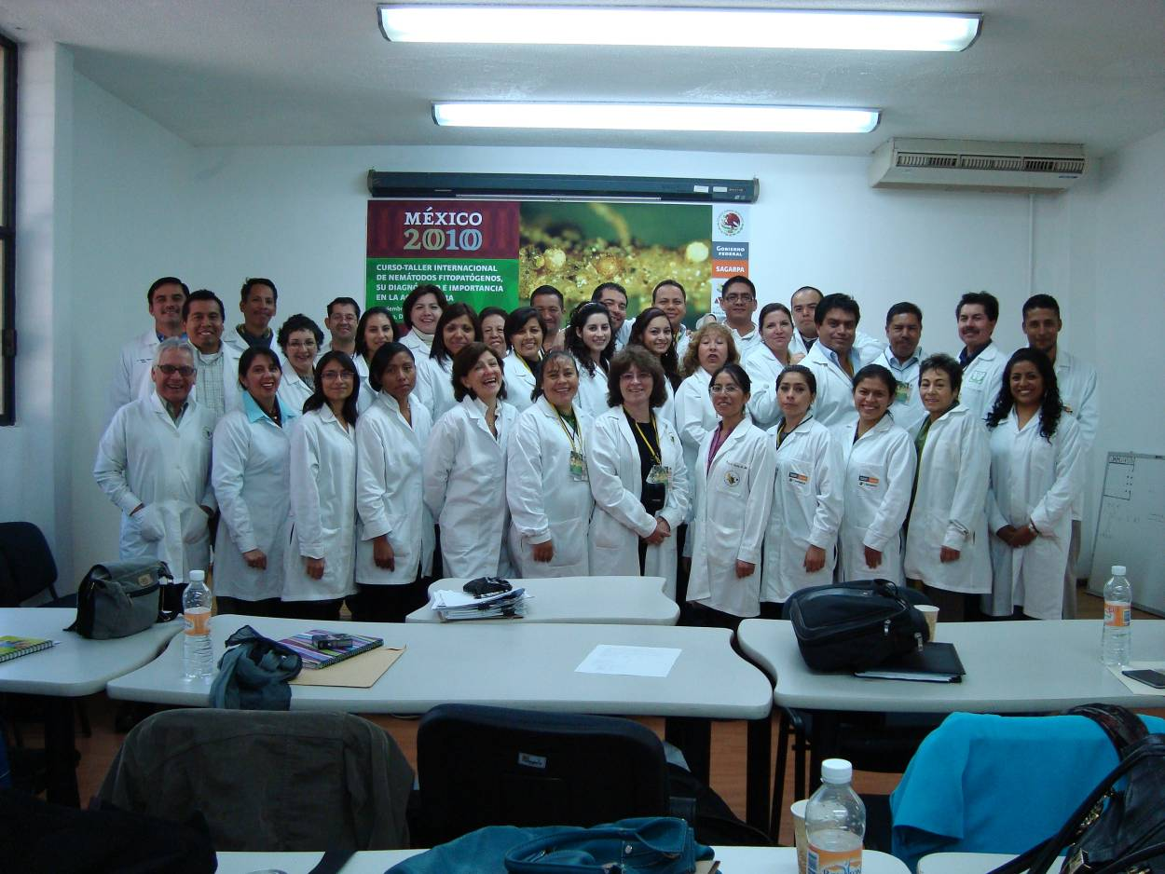
Instructors and students involved in the course. Note in the first row ONTA members Manuel Mundo-Ocampo (1st from left), Mariella Finetti-Sialer (5th from left), Rosa Manzanilla-López (7th from left) and ONTA president Emma Zavaleta-Mejia (2nd from right).

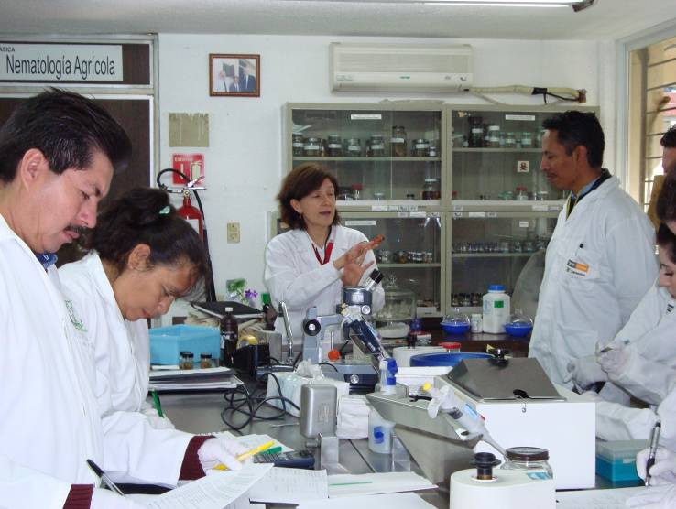 Mariella Finetti-Sialer (center) training students.

NEMATOLOGY INITIATIVE FOR EAST AND SOUTHERN AFRICA

The Nematology Initiative for East and Southern Africa (NIESA) is a Gatsby Foundation funded project that was initiated by Brian Kerry, David Hunt and Simon Gowen with the support of Rothamsted International (lead by Judy Mann) in order to build up nematological skills and expertise among agricultural specialists and scientists in Kenya, Malawi, Tanzania, Uganda and Zimbabwe. In November 2010, Rosa Manzanilla-López and Keith Davies (Rothamsted Research, UK) went to Nairobi to meet with NIESA members and to discuss activities necessary to strengthen Plant Nematology in the region. Their mission was to revamp the project and consolidate NIESA as a nematology group, which includes Prof. Waceke Wanjohi (Kenyatta University), Dr Busi Sibanda (Zimbawe), Dr Herbert Talwana (Uganda), Dr John Kimenju (University of Nairobi), and Dr Nessi Lumbuano (Tanzania). ONTA members commend Rosa and Keith for fostering Nematology in African countries.

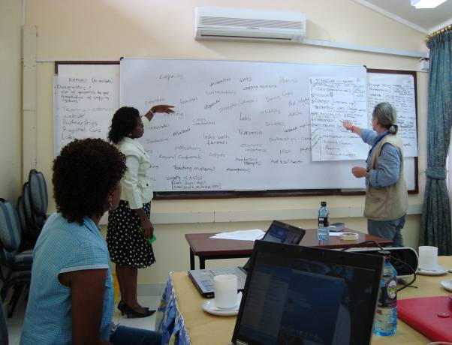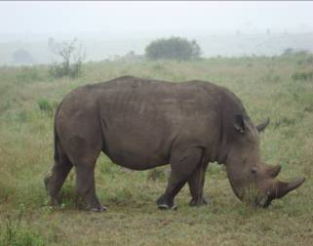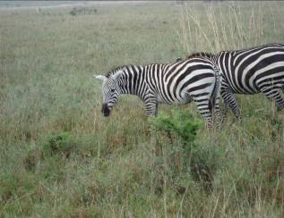
Keith Davies (right) with Waceke and Busi An aspect of Kenya’s wildlife.
during a brain storming session.

ONTA OFFICERS
PRESIDENT: Emma Zavaleta-Mejía, Fitopatología, Instituto de Fitosanidad, Colegio de Postgraduados. Km 35.5 Carretera México-Texcoco, Estado de México, México; Tel: 52-595-9520265 ext. 1625. E-mail: <zavaleta@colpos.mx>.
VICE-PRESIDENT: Erwin Aballay, Dept. Sanidad Vegetal, Fac. Ciencias Agrarias, Universidad de Chile. P.O. Box 1009. Santiago, Chile. E-mail: <eaballay@abello.dic.uchile>.
PAST PRESIDENT: S. Patricia Stock, Department of Entomology, University of Arizona, Forbes Bldg. Rm 410 1140 E. South Campus Drive, Tucson, AZ 85721-0036 USA; Tel: 1-520-626-3854 or 520-621-1317; FAX: 1-520-621-1150;e-mail: <spstock@ag.arizona.edu>.
SECRETARY: Paola Lax, Universidad Nacional de Córdoba, Laboratorio de Nematología, Centro de Zoología Aplicada, Casilla de Correo 122, 5000 Córdoba, Argentina; Tel: 54-351-433-2055 ext.105; FAX: 54-351-432055 ext. 101 e-mail: <plax@efn.uncor.edu> and <laxpaola@yahoo.com.ar>.
TREASURER: : Renato N. Inserra, Florida Department of Agriculture and Consumer Services, Division of Plant Industry, Nematology Section, P.O. Box 147100, Gainesville FL 32614-7100, USA. Tel: 1-352-372-3505, Ext. 115; FAX: 1-352-955-2301 or 2300; e-mail: <renato.inserra@freshfromflorida.com>.
NEMATROPICA EDITOR: Editor-in-Chief: Katheryn S. Lawrence, Auburn University, Department of Plant Pathology, 227 Life Science Blvd., Auburn, AL 36849 USA; Tel: 334-844-1956; FAX: 334-844-1947; <lawrekk@auburn.edu>.
NEWSLETTER EDITOR: Renato N. Inserra, Florida Department of Agriculture and Consumer Services, Division of Plant Industry, Nematology Section, P.O. Box 147100, Gainesville FL 32614-7100, USA. Tel: 1-352-372-3505, Ext. 115; FAX: 1-352-955-2301 or 2300; e-mail: <renato.inserra@freshfromflorida.com >.
MEMBERS AT LARGE: Rosa H. Manzanilla-López, Nematode Interactions Unit, PPM, Rothamsted Research, Harpenden, Herts AL5 2JQ, United Kingdom or 16 Coleswood Road, Harpenden, Herts, AL5 1EQ, UK, Tel: 44-1582-763133 ext. 2755. e-mail: <rosa.manzanilla-lopez@bbrc.ac.uk> or <rosa.manzanilla@gmail.com>. Nahúm Marbán-Mendoza, Departamento de Parasitologia Agrícola, Universidad Autonoma de Chapingo, Montecillo, Edo. de Mexico, Chapingo 56230, Mexico. FAX: 52-595-40692; e-mail: <nmarbanm@yahoo.com.mx> or <nahumm@correo.chapingo.mx>..

COMMITTEES AND REPRESENTATIVES
ARCHIVE COMMITTEE: Robert McSorley, Department of Entomology and Nematology, University of Florida, P.O. Box 110620, Gainesville FL 32611-0620, USA; Tel: 1-352-392-1901, Ext. 137; FAX: 1-352-392-0190; e-mail:<rmcs@gnv.ifas.ufl.edu>
FOUNDATION COMMITTEE: Charles Overstreet (Chair), Louisiana Cooperative Extension Service, P.O. Box 25100, Baton Rouge LA 70894-5100, USA; Tel: 1-225-388-2186; FAX: 1-225-388-2478; e-mail: <coverstreet@agctr.lsu.edu>. Paula Agudelo 120 Long Hall, Clemson University, Clemson, SC 29634, U.S.A. Tel:1-864-656-5739; e-mail: <pagudel@clemson.edu>; Alejandro Esquivel, Lab. Nematología, Escuela de Ciencias Agrarias, Universidad Nacional, AP 86-3000, Heredia, Costa Rica. Tel: 277 32 99; FAX: 261 00 35; e-mail:< aesquive@una.ac.cr>. Jenny Escobar, Junin 116 y Panama, Guayaquil Guayas 09-13293, Ecuador; e mail: <jenny.escobar@bayercropscience.com>. Patrick Quénéhervé (see address under Executive Committee). Jim Rich, (see address under Home Page Committee). Marta Susana del Toro, Laboratorio de Nematologia Vegetal, Facultad de Ciencias Agrarias, Almirante Brown 500, 5505 Chacras de Coria, Luján, Mendoza, Argentina. Tel:54-61-960004, ext.2030; FAX:54-61-960469; e-mail: <mdeltoro@fca.uncu.edu.ar>.
HONORS AND AWARDS COMMITTEE: Jenny Escobar (Chair), Junin 116 y Panama, Guayaquil Guayas 09-13293, Ecuador; e mail: <jenny.escobar@bayercropscience.com>. Javier Franco, Fundación PROINPA Foundation, Casilla Postal 4285, Av. Meneces, Km 4, El Paso, Cochabamba, Bolivia;Tel.: 00 591 4319595; Fax: 00 591 4319600; e-mail: <j.franco@proinpa org>. Renato N. Inserra, (address under Executive Committee); Julia A. Meredith, PO Box 140357, Gainesville, FL 32614-0357, U.S.A.;e- mail:<julia@nersp.nerdc.ufl.edu>. Nahúm Marbán-Mendoza, Departamento de Parasitologia Agrícola, Universidad Autonoma de Chapingo, Montecillo, Edo. de Mexico, Chapingo 56230, Mexico. FAX: 52-595-40692; e-mail: <nmarbanm@yahoo.com.mx> or <nahumm@correo.chapingo.mx>. Manuel Mundo-Ocampo, Department of Nematology, University of California Riverside, Riverside, CA 92521-0415, U.S.A.; Tel. 1-951-827-7313; e-mail: <manuel.mundo@ucr.edu>. Patrick Quénéhervé, ORSTOM Laboratoire de Nématologie, BP 8006-97259 Fort de France Cedex, Martinique (French West Indies). Tel: 596-645750; FAX: 596-717316; e-mail: <queneherve@ird-mq.fr>. Rodrigo Rodríguez-Kábana (see address under Executive Committee).
LOCAL ARRANGEMENTS COMMITTEE: Isabel M. de O. Abrantes (Chair), Departamento de Zoologia, University of Coimbra, Coimbra, Portugal; e-mail: <Isabel.abrantes@zoo.uc.pt>.
NEMATROPICA EDITORIAL COMMITTEE: Katheryn S. Lawrence (Chair) (see address under Executive Committee). Nancy Kokalis Burelle (Past Editor-in-chief), USDA, ARS, U. S. Horticultural Research Lab., 2001 South Rock Rd., Ft. Pierce, FL 34945; Phone: (772) 462-5861; Fax: (772) 462-5986; Cell: (772) 216-0560; Email: <nancy.burelle@ars.usda.gov>. Paula Agudelo (Senior Editor, Spanish), 120 Long Hall, Clemson University, Clemson, SC 29634, U.S.A.; Manuel Mota (Senior Editor Portuguese) , Departamento Biologia, Universidade de Evora, Evora 7000 Portugal; Tel:35-1-266-760800; e-mail:<mmota@uevora.pt>; Patrick Quénéhervé (Senior Editor, French)(address under Nomination Committee); Janete Brito (Business Manager), Florida Department of Agriculture and Consumer Services, Division of Plant Industry, Nematology Section, P.O. Box 147100, Gainesville FL 32614-7100, USA. Tel: 1-352-372-3505, Ext. 115; FAX: 1-352-955-2301 or 2300; e-mail: < britoj@doacs.state.fl.us >. Associate Editors as listed in Nematropica. Larry W. Duncan, (Editor of the electronic version of Nematropica), University of Florida, Citrus Research and Education Center, 700 Experiment Station Road, Lake Alfred FL 33850-2299, USA; Tel: 1-863-956-1151; FAX: 1-863-956-4631; e-mail: <lwduncan@ufl.edu> or <lwdn@crec.ifas.ufl.edu>.
NEWSLETTER COMMITTEE: Renato N. Inserra (Chair), (see address under Executive Committee); Debby Monfort, Editor, Arkansas Plant Pathology, University of Arkansas, Department of Plant Pathology, Hope, AR 71801 USA, Tel: 501-438-2044; e-mail: <dmonfort@uark.edu>.Renato Crozzoli, Univ. Central de Venezuela, Instituto de Zoologia Agricola, Apartado 4975-A, Maracay, Aragua 2101, Venezuela. FAX: 58-43-507085; e-mail: <renatocrozzoli@gmail.com>.
NOMINATIONS COMMITTEE: Patrick Quénéhervé (Chair), ORSTOM Laboratoire de Nématologie, BP 8006-97259 Fort de France Cedex, Martinique (French West Indies). Tel: 596-645750; FAX: 596-717316; e-mail: <queneherve@ird-mq.fr>.Jimmy Rich, University of Florida, 155 Research Road, Quincy FL 32351-9500, USA. Tel: 1-850-875-7130; FAX: 1-850-875-7148; e-mail: <Jimmyr@ufl.edu>. Renato N. Inserra, (address under Executive Committee); Nahúm Marbán-Mendoza, Departamento de Parasitologia Agrícola, Universidad Autonoma de Chapingo, Montecillo, Edo. de Mexico, Chapingo 56230, Mexico. FAX: 52-595-40692; e-mail: <nahumm@taurus1.chapingo.mx>. Nicola Greco, Istituto per la Protezione delle Piante, Sezione di Bari, Via Amendola, 165/A, 70126 Bari, Italy. Tel: 39 080 5484186; e -mail: <n.greco@ba.ipp.cnr.it>. Renata C. V. Tenente, EMBRAPA, CENARGEN, Sain Parque Rural, Cx. P. 2372, Brasilia D.F. 70849-970, Brazil. Tel: 55-61-348-1623; FAX: 55-61-348-4700; e-mail: <renata@cenargen.embrapa.br>. Juan Carlos Magunacelaya, Avda. Brasil 2950, Valparaiso 4059, Chile, Tel: 56 2 678 5821; e -mail: <jmagunac@ucv.cl>.
SUSTAINING MEMBER COMMITTEE: Luis A. Payan (Chair), Syngenta Crop Protection, PO Box 18300, Greensboro NC 27409, U.S.A. Tel: 336-632-6000; e -mail: <luis.payan@syngenta.com>. Janete A. Brito, Florida Department of Agriculture and Consumer Services, Division of Plant Industry, Nematology Section, P.O. Box 147100, Gainesville FL 32614-7100, USA. Tel: 1-352-372-3505, Ext. 115; FAX: 1-352-955-2301 or 2300; e-mail: < britoj@doacs.state.fl.us >. Donald W. Dickson, University of Florida, Entomology and Nematology Department, Gainesville, FL 32611-0620, U.S.A. Tel: 352-392-1901 (135); e-mail:<dwd@ufl.edu>. Jenny Escobar, Junin 116 y Panama, Guayaquil Guayas 09-13293, Ecuador; e mail: <jenny.escobar@bayercropscience.com>. Gustavo Fallas Meji, Apartado 4595-1000, Edificio Rodfon C5 y Av.1, San Jose, Costa Rica. E-mail < gfallas@chiquita.com>. Jimmy Rich, (See address under Nominations Committee). Prem Warrior, Valent BioScience Corporation, 6131 RFD, Oakwood Road, Long Grove, IL 60047, U.S.A. Tel.:1-847-968-4901; Fax: 1-847-968-4970; e-mail: <prem.warrior@valent.com>.
WEB PAGE COMMITTEE: Terrence L. Kirkpatrick (Chair), University of Arkansas, Southwest Research and Extension Center, 362 Highway 174 North, Hope, AR 71801 USA, Tel: 501-777-9702; FAX: 501-777-0963; e-mail: <tkirkpatrick@uaex.edu>. Erwin O. Aballay, Universidad de Chile, Fac. Ciencias Agrarias, Dept. Sanidad Vegetal, P.O. Box 1004 or Avenida Santa Rosa # 11.135, La Pintana, Santiago, Chile. Tel: 56-2-6785821 or 56-9-4346229; FAX: 56-2-6785812; e-mail: <erwinaba@uchile.cl>. Leopoldo Hidalgo, Centro Nacional de Sanidad Agropecuaria (CENSA), Apartado 10, San José de las Lajas, Habana, Cuba <lhidalgo@censa.edu.cu>. César Ornat Longaron (Co-Chair), Dep. Enginiyria Agroalimentária i Biotecnologia, Universitat Politecnica de Catalunya, Avinguda del Canal Olímpic s/n, 08860 Castelldefels, Barcelona Spain. Tel:34-935-521-072; FAX: 34-935-521-001; e-mail:<Cesar.Ornat@upc.edu>. Debby Monfort, Editor, Arkansas Plant Pathology, University of Arkansas, Department of Plant Pathology, Hope, AR 71801 USA, Tel: 501-438-2044; e-mail: <dmonfort@uark.edu>. Jimmy Rich, (See address under Nominations Committee). Miguel Talavera Rubia, Area de Protección de Cultivos, IFAPA, Centro Camino de Purchil, Instituto de Investigación y formación Agraria y Pesquera. Junta de Andalucía, Apdo. Correos 2027, 18080-Granada, Spain. Tel.: 958 895 251; Fax: 958 895 203; e-mail: <miguelf.talavera.ext@juntadeandalucia.es>.
REGIONAL REPRESENTATIVES: Edwin Aballay, Universidad de Chile, Fac. Ciencias Agrarias, Dept. Sanidad Vegetal, P.O. Box 1004 or Avenida Santa Rosa # 11.135, La Pintana, Santiago, Chile. Tel: 56-2-6785821 or 56-9-4346229; FAX: 56-2-6785812;e-mail: <erwinaba@uchile.cl>. Janete Brito, address under Nematropica Editorial Committee, Ana M. Casassa, Universidad del Zulia, Facultad de Agronomía, Instituto de Investigaciones Agronomicas, Ciudad Universitaria, Núcleo Agropecuario, Av. 16 (Guajira), Maracaibo, ZU 4005, Venezuela. E-mai: <casassae@cantv.ve>. Alejandro Esquivel, Lab. Nematología, Escuela de Ciencias Agrarias, Universidad Nacional, AP 86-3000, Heredia, Costa Rica. Tel: 277 32 99; FAX: 261 00 35; e-mail:< aesquive@una.ac.cr>. Eleodoro Herrera Alvariño, Calle 27 No. 376 Urbanizacion Córpac, San Isidro, Lima, Peru; e-mail <eherrera@hotmail.com> Francisco Franco-Navarro, Phytopathology Program-Colegio de Postgraduados, Montecillo 56230, Mexico State, Mexico. E-mail; <ffranco@colpos.mx>. Paola Lax, address under Executive Committee. Mayra G. Rodríguez, Laboratorio de Nematología, Centro Nacional Agropecuario (CENSA), Apartado 10, San José de Las Lajas, Havana, Cuba; Tel: 53 64 63014 ext. 48; e-mail <mrguez@censa.edu.cu>. Betty Tello, Junin 116 y Panama, Guayaquil Guayas 09-13293, Ecuador; e mail: <jenny.escobar@aventis.com>. Myrian Tigano, CENARGEN- EMBRAPA, Pq. EB - Av. W 3 Norte Final, Brasilia, DF, 70770-970, Brazil. Tel: 55-61-4348-4678; E-mail: <myrian@cenargen.embrapa.br>. Soledad Verdejo-Lucas, IRTA, Departamento de Protección Vegetal, Carretera de Cabrils S/N, Cabrils (Barcelona), Spain, Tel:34-93-750-7511; FAX:34-93-753-3954; e-mail: <soledad.verdejo@irta.es>.

REPRESENTATIVES IN THE IFNS: Aurelio Ciancio, Istituto per la Protezione delle Piante, C.N.R., Sezione Bari, via Amendola 165/A, 70126 Bari, Italy; Tel:39-80-5929-221;FAX:39-80-5929-230;e-mail: <a.ciancio@ba.ipp.cnr.it>. Rodrigo Rodríguez-Kábana (see address under Executive Committee).

